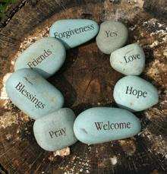
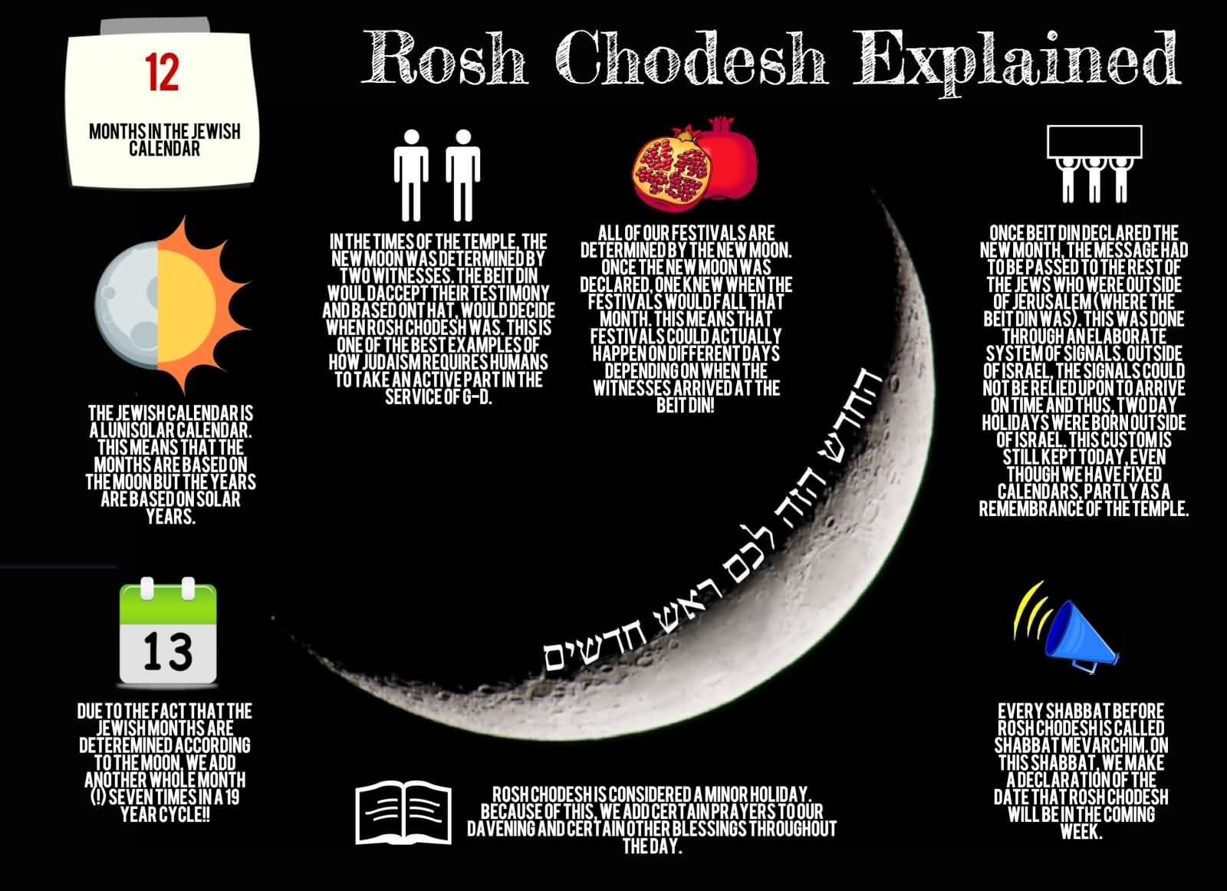
Women’s League of B’nai Torah Congregation presents a Rosh Chodesh Healing Circle
Dates: Thursday, November 4th (Kislev); Sunday, December 5th (Tevet); Tuesday, January 4th (Shevat); Tuesday, February 1st (Adar I); Thursday, March 3rd (Adar II); Sunday, April 3rd (Nisan); Monday, May 2nd (Iyar); Tuesday, May 31st (Sivan)
Time: 6:30 PM – 7:30 PM
Facilitators for Healing Circle:
- Sue Gurland, Spiritual Director and creator of Moving Through the Tree of Life
- Reb Tuviah, musician, song leader and Rabbi of Temple Beth David in Springhill, Florida

Bring a candle to light.
Start each new month with an uplifting evening of song, prayer, teachings and meditation. Experience how to use the Kabbalistic energies associated with each season and Jewish holiday to heal ourselves and those we care for. Everyone, women and men, are welcome. Email Sue at suegboca@gmail.com for the Zoom link.
No prior experience, knowledge or reading Hebrew is required. It’s an evening of song, reflection and prayer connected to the Jewish calendar.

Join us and invite your friends! Questions? Email Sue Gurland at suegboca@gmail.com Click HERE to find out why Rosh Chodesh is a women’s holiday.

