TBS PINK SHABBAT

On Saturday, January 13, Temple Beth Sholom Sisterhood, Cherry Hill, combined their Sisterhood Shabbat and a Chesed Project. They honored breast cancer survivors and all those suffering from the disease at “Pink Shabbat”. Their Sisterhood partnered with Sharsheret, an organization offering a community of support to Jewish women diagnosed with breast cancer, and Distributing Dignity, an organization that supports women in need and brings dignity in the process. They collected new bras and feminine products to donate to Distributing Dignity.
Debbie Zimmerman, Sisterhood President said: “It was absolutely magical. I felt like a proud Mama Bear! The women were prepared, professional and polished. Many women were reading Torah or leading parts of the service for the very first time. The Torah portion was about survival which tied into our Pink Shabbat theme seamlessly. We had 4 breast cancer survivors tell their story of strength and survival as part of the D’Var Torah. They all emphasized that they were lucky to now realize the power of family, friendship and community. There was not a dry eye in the house. We honored breast cancer survivors with a group Aliyah, and the power of seeing so many survivors up on the Bimah at one time was overwhelming.

Everyone was dressed in pink. Women wore pink dresses, shoes, scarves and men adorned pink shirts and ties. The foyer tables and social hall were decorated with info from Sharsharet and Distributing Dignity. We had pink kippot, cookies, pink Champagne and pink decorations. (Pictures below were taken at set up time, not Shabbat).

We have made a year-long project of collecting new bras and feminine hygiene products for Distributing Dignity and are having great success. We have a Sisterhood Shabbat every year. I have to say that this year was different. While always a wonderful morning, this year had a magical feel to it. I think we all felt that we were part of something bigger and more meaningful. For me, it was a highlight of my presidency. It truly was superb!”

If anyone is interested in hosting a Pink Shabbat, you may contact Debbie for ideas at: debrazimmerman1@gmail.com

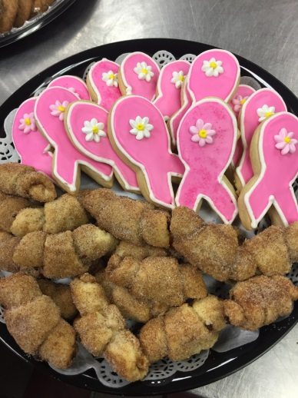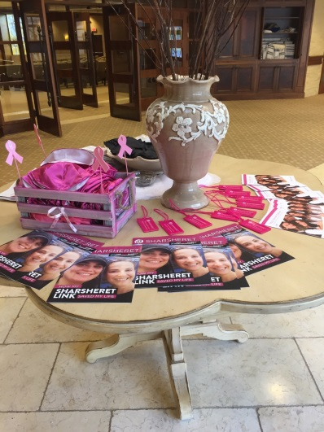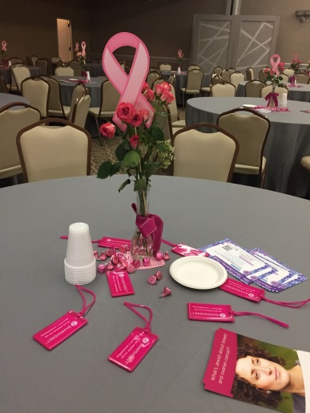
Everything at “Pink Shabbat” at TBS had the breast cancer theme, from the cookies to the centerpieces. Kippot and candies were pink, and informational material was available about Sharsheret and Distributing Dignity

