Mathildes Mentionables

Temple Israel Sisterhood Project
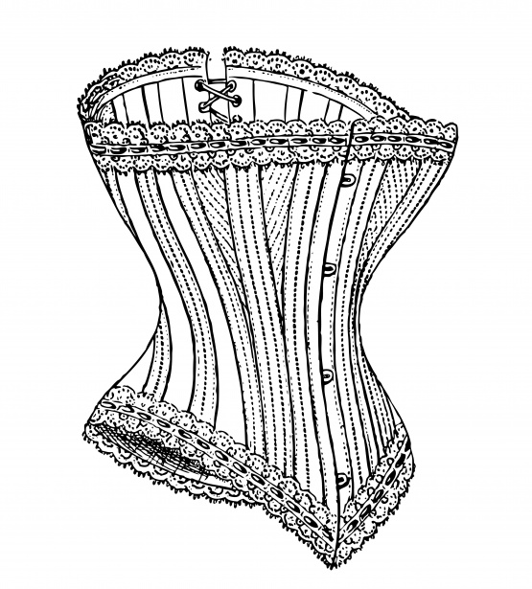

The Women’s League for Conservative Judaism (WLCJ) began a new social action project in 2017 called Mathildes Mentionables (in honor of our founder Mathilde Schechter) which collects new and gently worn bras for women in need through the Support the Girls organization.

Temple Israel Sisterhood is supporting this project by collecting NEW and GENTLY WORN AND WASHED bras and NEW packages of underwear and unopened/unused feminine hygiene products.

Products will be collected through Tue, Jan 9, 2018 in both the Women’s Locker Room and the (Oasis) Weinberg Center of the Levine Jewish Community Center and can also be dropped off at Temple Israel from Jan 9–12 in bins located in the front lobby. Once collected, the items will be sorted and bagged by volunteers during YOM GEMILUT HASADIM at Temple Israel on Sun, Jan 14th.

If you have questions concerning the drop off or if you’d like more information about the project, please contact:
- Chair - Hilary Rosenbaum at 704-321-0625 or dhrose4@gmail.com
- Co-Chair - Gail Weinstein Halverson at gailandnorman14@gmail.com.

We greatly appreciate your support!

